**Problem sheet 4 :: experimental design**

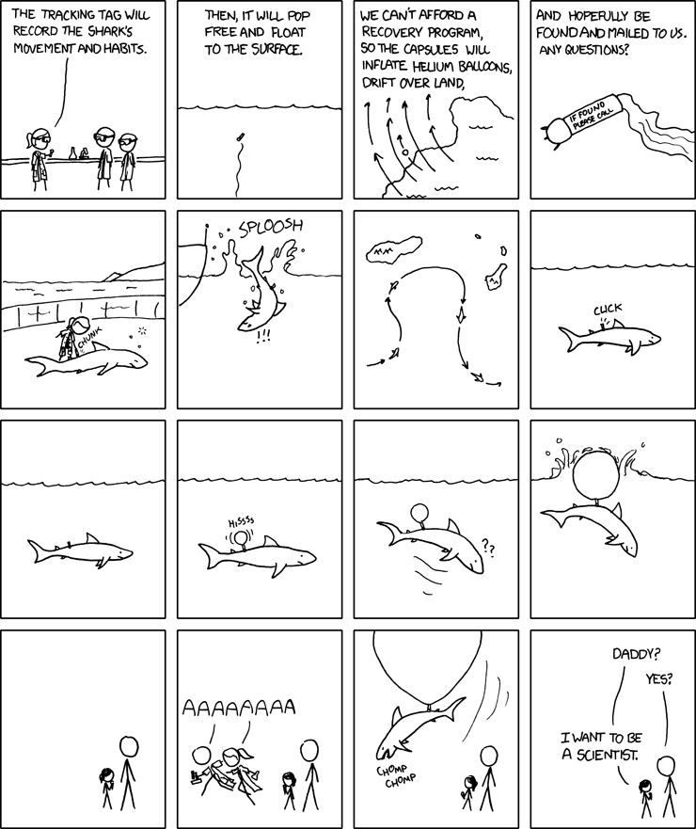

**Questions**

Three questions, each worth 3 marks with 1 mark for attendance.

Q1. Acupuncture is a treatment derived from ancient Chinese medicine. Fine needles are inserted at specific sites in the human body for therapeutic or preventative purposes. You want to devise an experiment to test if acupuncture is efficient to release back pain. Imagine you are the researcher behind this research question and think (answer) about the following:

* What is your dependent variable? What are you measuring and how are you measuring it?
* What is your independent variable? To help you with this, you need to compare two conditions, what are they?
* Is your study within or between participants and why?
* How will you assign participants to the different groups?
* Describe the study procedure, i.e. what is happening from the moment participants arrive to the moment they leave.
* DV = back pain score (e.g. you can use a Likert). You can potentially ask them they score before and after using a questionnaire
* IV = condition 1 = acupuncture / condition 2 = “fake” acupuncture. You need to somewhat make the participants think they get acupuncture to test the placebo condition.
* The study needs to be between, one group has the acupuncture, the other one not, there is no other way to do it
* You need to assign them randomly to avoid biases, e.g. putting people who looks in more pain in the same group.
* Procedure: participants arrives, the study is explained, they fill in a questionnaire about pain, they get the acupuncture (or not) without being told which one it is, they then fill in the exit questionnaire.

Q2. A talented researcher who is passionate by his research has invented a pill who he claims make people happier. He set out to investigate if his pill works by giving it to a bunch of people. A week later, he invites the participants in his lab, sat them at a table on front of him, and ask them if they feel happier than before. He records the number of times participants replied positively which allows him to claim that his pill does indeed work.

* Think about two things that are wrong with this experimental setup and propose solutions.
* The study should be comparing to a baseline, i.e. a placebo pill
* The study should be using double blind: the experimenter cannot know which pills the participant took
* The researcher here is obviously biasing the experiment by sitting in front of the participants, he could influence the answers.

Q3. The Milgram Experiment was conducted in 1961 by psychologist Stanley Milgram and was designed to measure the lengths that people would go to in obedience to authority figures, even if the acts they were instructed to carry out were clearly harmful to others. Subjects were told to play the role of teacher and administer electric shocks to the learner, an actor who was out of sight and ostensibly in another room, every time they answered a question incorrectly. In reality, no one was actually being shocked. The learner, purposely answering questions wrongly, was made to sound like they were in a great deal of pain as the intensity of the shocks increased with each incorrect answer. Despite these protests many subjects continued to administer shocks when an authority figure, the 'experimenter,' urged them to. Eventually, 65% of subjects administered what would be lethal electric shocks, the highest level of 450 volts. The results showed that ordinary people are likely to follow orders given by an authority figure, even to the extent of killing an innocent human being. Obedience to authority is simply ingrained in us all, from the way we are brought up as children.

This experiment is a famous example of how ethically wrong a study can be. For example, researchers should make it plain to participants that they are free to withdraw at any time (regardless of payment). But the experimenter gave four verbal prods which mostly discouraged withdrawal from the experiment: “Please continue”; “The experiment requires that you continue”; “It is absolutely essential that you continue”; “You have no other choice, you must go on”. This is against what we call “Right to Withdrawal”.

What else is ethically wrong with this experiment and particularly for the participants?

* **Deception**: the participants actually believed they were shocking a real person and were unaware the learner was a confederate of Milgram's.
* **Protection of participants**: participants were exposed to extremely stressful situations that may have the potential to cause psychological harm.

**More links**

[1] Goldacre, B. (2010). Bad science: Quacks, hacks, and big pharma flacks. McClelland & Stewart.

[2] Miller, A. (2016). Why are the Milgram Obedience Experiments still so extraordinarily famous-and controversial. *The Social Psychology of Good and Evil*, 185-223.